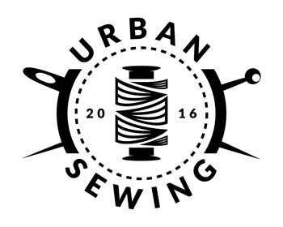
Custom Bag Template
Fill out this template, then copy & paste into Custom Order link on www.urbansewingstl.etsy.com

Bag Type: ___________________________________________
Size: _______________________________________________
Color Scheme: _______________________________________
Upcyclable Bag #: _____________________________________
Strap Preference: ____________________________________
Pocket Preferences: ___________________________________
Add On(s): ___________________________________________
Other comments or requests: ___________________________
____________________________________________________
____________________________________________________
____________________________________________________

